**11/12** 

**Contemporary Philippine Arts from the Regions**

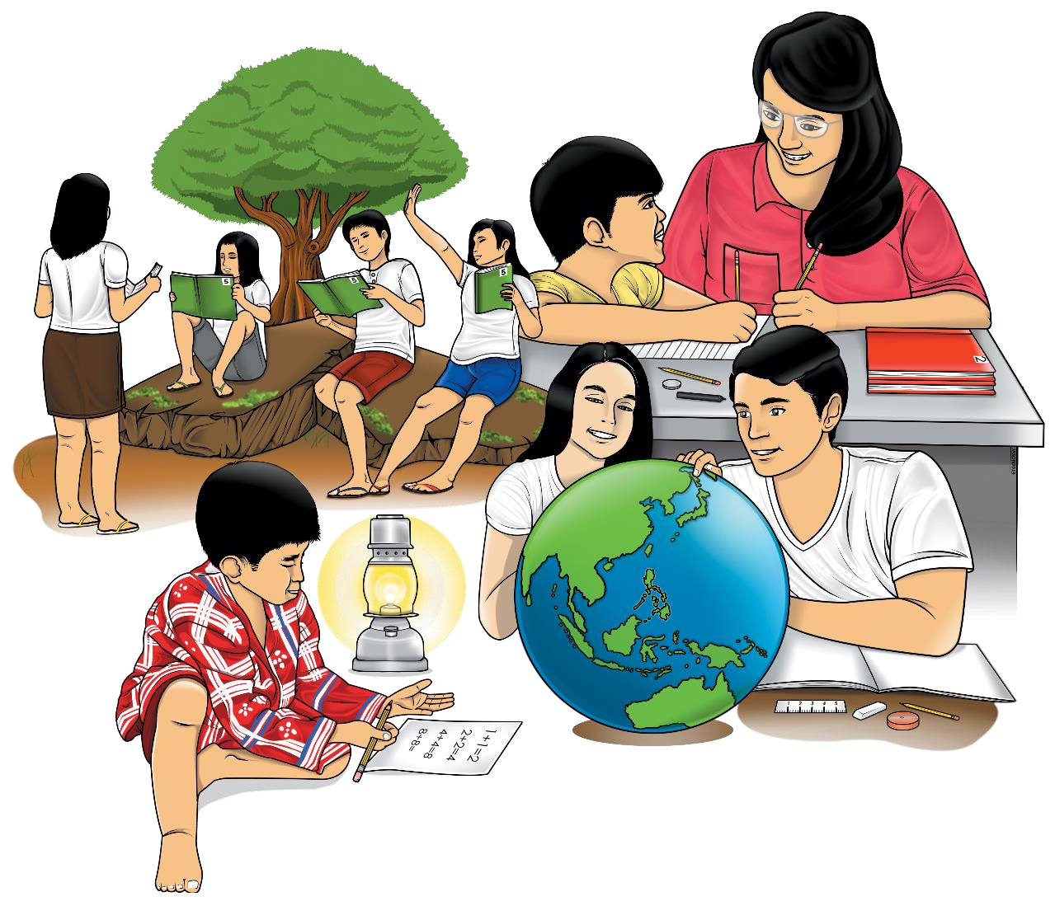

**Quarter 2 – Module 7-8**

**Lesson 1. Incorporate Contemporary Characteristics to One’s Creation**

**Lesson 2. Creation of Final Product**

**Contemporary Philippine Arts from the Region – Grade 11/12**

**Alternative Delivery Mode**

**Quarter 2– Module 3: Lesson 1. Conceptualize Contemporary Art Based on Techniques and Performance Practices**

**Lesson 2. Artistic Skills and Techniques**

**First Edition, 2020**

**Republic Act 8293, section 176** states that: No copyright shall subsist in any work of the Government of the Philippines. However, prior approval of the government agency or office wherein the work is created shall be necessary for exploitation of such work for profit. Such agency or office may, among other things, impose as a condition the payment of royalties.

Borrowed materials (i.e., songs, stories, poems, pictures, photos, brand names, trademarks, etc.) included in this module are owned by their respective copyright holders. Every effort has been exerted to locate and seek permission to use these materials from their respective copyright owners. The publisher and authors do not represent nor claim ownership over them.

Published by the Department of Education, Tagbilaran City Division

Secretary: SDS Joseph Irwin A. Lagura, Ed.D

Undersecretary: ASDS Marcelo K. Palispis, Ed.D.

|  |
| --- |
| **Development Team of the Module**  **Writer/s:** Rochelle Margaret C. Real  Faustino Rey T. Hormiguera  Dennis L. Bigcas  **Editors:** Rochelle Margaret C. Real  Faustino Rey T. Hormiguera  Dennis L. Bigcas  **Reviewers:** Mark Vincent Ranay  Alberto A. Lacang  **Management Team:**  SDS Joseph Irwin A. Lagura, Ed.D  Division CID Chief John Ariel A. Lagura, PhD  Division EPS In charge of LRMDS Neolita S. Sarabia, PhD |

**Printed in the Philippines by**

**Department of Education – Region VII | Tagbilaran City Division**

Office Address: Rajah Sikatuna St., Dampas , Tagbilaran City Bohol, Philippines 6300 Telephone Nos. (038)427-1702; (038)427-2506

E-mail Address: dtagbilarandivision@yahoo.com

# 11/12

**Contemporary Philippine Arts**

**From the Region**

**Quarter 1 – Module 7-8**

**Lesson 1. Incorporate Contemporary Characteristics to One’s Creation**

**Lesson 2. Creation of Final Product**

FAIR USE AND CONTENT DISCLAIMER: This SLM (Self Learning Module) is for educational purposes only. Borrowed materials (i.e., songs, stories, poems, pictures, photos, brand names, trademarks, etc.) included in these modules are owned by their respective copyright holders. The publisher and authors do not represent nor claim ownership over them. Sincerest appreciation to those who have made significant contributions to these modules.



**Introductory Message**

For the facilitator:

Welcome to the Contemporary Philippine Arts from Region -11/12 Alternative Delivery Mode (ADM)

This module was collaboratively designed, developed and reviewed by educators both from public and private institutions to assist you, the teacher or facilitator in helping the learners meet the standards set by the K to 12 Curriculum while overcoming their personal, social, and economic constraints in schooling.

This learning resource hopes to engage the learners into guided and independent learning activities at their own pace and time. Furthermore, this also aims to help learners acquire the needed 21st century skills while taking into consideration their needs and circumstances.

In addition to the material in the main text, you will also see this box in the body of the module:

***Notes to the Teacher***

This contains

helpful tips or strategies

that

will

help you in guiding the learners.



As a facilitator you are expected to orient the learners on how to use this module. You also need to keep track of the learners' progress while allowing them to manage their own learning. Furthermore, you are expected to encourage and assist the learners as they do the tasks included in the module.

For the learner:

Welcome to the Contemporary Philippine Arts from Region-11/12 Alternative Delivery Mode (ADM) Module on **Defining Contemporary Art**!

The hand is one of the most symbolized part of the human body. It is often used to depict skill, action and purpose. Through our hands we may learn, create and accomplish. Hence, the hand in this learning resource signifies that you as a learner is capable and empowered to successfully achieve the relevant competencies and skills at your own pace and time. Your academic success lies in your own hands!

This module was designed to provide you with fun and meaningful opportunities for guided and independent learning at your own pace and time. You will be enabled to process the contents of the learning resource while being an active learner.

This module has the following parts and corresponding icons:

|  |  |  |  |
| --- | --- | --- | --- |
| |  |  | | --- | --- | | C:\Users\DEPED\Desktop\ADM specs\ADM cover and icons\ADM Icons\Alamin2.jpg | ***What I Need to Know*** | | This will give you an idea of the skills or competencies you are expected to learn in the module. |
| |  |  | | --- | --- | | C:\Users\DEPED\Desktop\ADM specs\ADM cover and icons\ADM Icons\What I Know.jpg | ***What I Know*** | | This part includes an activity that aims to check what you already know about the lesson to take. If you get all the answers correct (100%), you may decide to skip this module. |
| |  |  | | --- | --- | | C:\Users\DEPED\Desktop\ADM specs\ADM cover and icons\ADM Icons\Balikan.jpg | ***What’s In*** | | This is a brief drill or review to help you link the current lesson with the previous one. |
| |  |  | | --- | --- | | C:\Users\DEPED\Desktop\ADM specs\ADM cover and icons\ADM Icons\Tuklasin.jpg | ***What’s New*** | | In this portion, the new lesson will be introduced to you in various ways such as a story, a song, a poem, a problem opener, an activity or a situation. |
| |  |  | | --- | --- | | C:\Users\DEPED\Desktop\ADM specs\ADM cover and icons\ADM Icons\suriin.jpg | ***What is It*** | | This section provides a brief discussion of the lesson. This aims to help you discover and understand new concepts and skills. |
| |  |  | | --- | --- | | C:\Users\DEPED\Desktop\ADM specs\ADM cover and icons\ADM Icons\whats more.jpg | ***What’s More*** | | This comprises activities for independent practice to solidify your understanding and skills of the topic. You may check the answers to the exercises using the Answer Key at the end of the module. |
| |  |  | | --- | --- | | C:\Users\DEPED\Desktop\ADM specs\ADM cover and icons\ADM Icons\Isaisip.jpg | ***What I Have Learned*** | | This includes questions or blank sentence/paragraph to be filled in to process what you learned from the lesson. |
| |  |  | | --- | --- | | C:\Users\DEPED\Desktop\ADM specs\ADM cover and icons\ADM Icons\Isagawa.jpg | ***What I Can Do*** | | This section provides an activity which will help you transfer your new knowledge or skill into real life situations or concerns. |
| |  |  | | --- | --- | | C:\Users\DEPED\Desktop\ADM specs\ADM cover and icons\ADM Icons\Tayahin.jpg | ***Assessment*** | | This is a task which aims to evaluate your level of mastery in achieving the learning competency. |
| |  |  | | --- | --- | | C:\Users\DEPED\Desktop\ADM specs\ADM cover and icons\ADM Icons\Additional Activities.jpg | ***Additional Activities*** | | In this portion, another activity will be given to you to enrich your knowledge or skill of the lesson learned. This also tends retention of learned concepts. |
| |  |  | | --- | --- | | C:\Users\DEPED\Desktop\ADM specs\ADM cover and icons\ADM Icons\Answer Key 2.jpg | ***Answer Key*** | | This contains answers to all activities in the module. |

At the end of this module you will also find:

|  |  |
| --- | --- |
| ***References*** | This is a list of all sources used in developing this module. |

The following are some reminders in using this module:

1. Use the module with care. Do not put unnecessary mark/s on any part of the module. Use a separate sheet of paper in answering the exercises.
2. Don’t forget to answer *What I Know* before moving on to the other activities included in the module.
3. Read the instruction carefully before doing each task.
4. Observe honesty and integrity in doing the tasks and checking your answers.
5. Finish the task at hand before proceeding to the next.
6. Return this module to your teacher/facilitator once you are through with it.

If you encounter any difficulty in answering the tasks in this module, do not hesitate to consult your teacher or facilitator. Always bear in mind that you are not alone.

We hope that through this material, you will experience meaningful learning and gain deep understanding of the relevant competencies. You can do it

### What I Need to Know

This module was designed and written with you in mind. It is here to help you describes various contemporary art forms and their practices from the various regions.. The scope of this module permits it to be used in many different learning situations. The language used recognizes the diverse vocabulary level of students. The lessons are arranged to follow the standard sequence of the course. But the order in which you read them can be changed to correspond with the textbook you are now using.

Most Essential Learning Competency:

* Conceptualize contemporary arts based on technique’s and performance practices in their locality (CAR11/12TPP-0c-e-14
* Applies artistic skills and techniques in the process of creation. CAR11/12TPP-0c-e-15

At the end of this module, you are expected to:

* Identify the technical characteristics of contemporary arts.
* Incorporates contemporary characteristics to one’s creation with attention to detail.
* Creates the intended product using appropriate materials for the best possible output.

### What I Know

**Pre-Test**

**MULTIPLE CHOICE**.Write the letter of the best answer from the choices.

1. Contemporary art is art that is living in _________________.

A. future times C. past times

B. present times D. mind

1. Neoplasticism uses _______________________.

A. straight lines and primary colors.

B. tapping into the unconscious mind to release creativity.

C. emphasizing the expressions of the self and emotions.

D. showing all the possible viewpoints of a person or an object all at

once

1. Surrealism art is focused on ____________________.

A. straight lines and primary colors.

B. tapping into the unconscious mind to release creativity.

C. emphasizing the expressions of the self and emotions.

D. showing all the possible viewpoints of a person or an object all at

once

1. This is a style of art that emphasizes the expressions of the self and emotions.

A. Fauvism C. Neoplasticism

B. Abstract expressionism D. Cubism

1. ___________ is often one of the most exciting components of a painting.

A. Technique C. Color

B. Design D. Medium

1. Sculptors used pieces of junk to produce what is now known as _______________.

A. poetry C. novel

B. painting D. junk art

1. Which of the following is not considered a warm color?

A. Blue C. Orange

B. Red D. Yellow

1. A technique is called __________ because the items represented in the artworks look like they are made from cubes and other geometrical shapes.

A. Fauvism C. Neoplasticism

B. Abstract expressionism D. Cubism

1. These colors bring a calming effect to the mind.

A. Cool colors C. Warm colors

B. Bright color D. Dark colors

1. Warm colors convey the following emotions expect ___________.

A. happiness C. excitement

B. violence D. dependability

|  |  |
| --- | --- |
|  | **Incorporate Contemporary Characteristics to One’s Creation** |



### What’s In

In previous module, we have learned the meaning of artistic skills and techniques. Many contemporary artists do not have formal studies in the fine arts. They develop their artistic skills and techniques by themselves. It is necessary study the medium and techniques used by contemporary artist to understand their work.

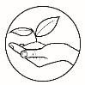

### What’s New

**ACTIVITY 1: WORD PUZZLE**

Mark with red ink instead of crushing out word/words that corresponds the characteristics of contemporary arts. Copy this on your answer sheet.

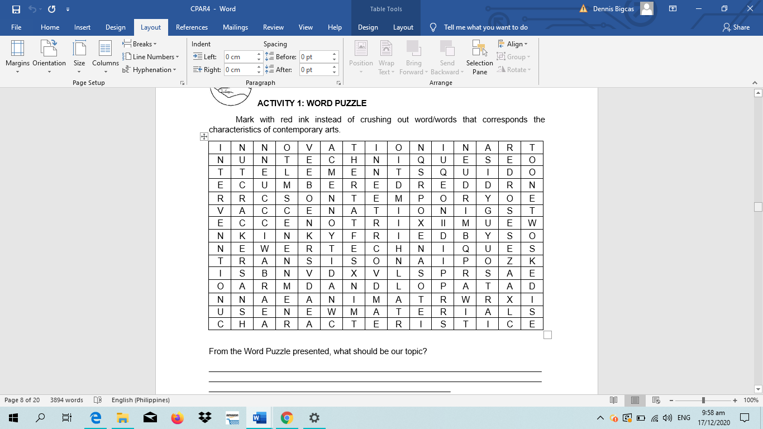

From the Word Puzzle presented, what should be our topic?

______________________________________________________________________________________________________________________________________________________________________________________________________________________________________________________________________________________________________

|  |  |  |
| --- | --- | --- |
| |  |  | | --- | --- | | C:\Users\DEPED\Desktop\ADM specs\ADM cover and icons\ADM Icons\suriin.jpg | ***What is It*** |   **TECHNICAL CHARACTERISTICS OF CONTEMPORARY ARTS**  The most prominent feature of contemporary art is the fact that it has no distinct feature or a single characteristic. It is defined by the artist’s ability to innovate and bring out a modern masterpiece. Here are a few of the technical characteristics:  **Innovation in Art**  From the meaning of contemporary, contemporary art is an art that is living in present times. It reflects current issues or current events. So, from time to time, it changes along with the society. It could sometimes break the rules of traditional art, created by modern humans.  Contemporary artists have been the pioneers in introducing new forms of art to the world. Different art forms have been combined or newer ideas employed to bring out newer types of art. It could be a public mood, and it could be an effect of being resourceful of any artist. Contemporary art guides us to have a reflection on our society and its issues in politics, economy, culture, and the like. Contemporary artists use their masterpieces to comment on cultural, political, and global issues, including race, feminism, human rights, civil, rights, gender equality, wars, economic inequality, and global conflicts.  A group of people wearing costumes  Description automatically generatedChange is a very significant aspect of humanity, still, art remains as part of living.  Collage art is an example of innovation that proved to be a great example of modern contemporary art. Likewise, mixed forms of assemblage, different variants of kinetic art as well as different categories of photography, animations and land art are a result of bringing together newer ideas.  Here are some contemporary art works that reflects the society.  https://bit.ly/352o7XH  undefined  Emmanuel Garibay. **Hangarin (Aspiration/Goal)**, *2008. Oil on canvas. 79 x 75 inches. Courtesy of the artist.*  **Hangarin (Aspiration/Goal)** is a depiction of the passionate Filipino interest in sports, especially basketball. The game is part of daily life for young men in particular, who enjoy its physicality and community appeal. In a dynamic, well observed work, Garibay illustrates a group of youths jostling on a court set in a closed if not confined urban environment.  https://bit.ly/3p2TclP  Emmanuel Garibay. **Pagpasok ni Kristo sa Maynila (Christ Entering Manila)**, *2008. Oil on canvas. 58 x 76 inches. Courtesy of the artist.*  In the crowded complexity of a street festival, so much a part of the rhythm of Filipino community life, we see the signs and symbols of faith and begin to look for the figure of Christ.  undefined    https://bit.ly/3p2TclP  undefined  Emmanuel Garibay. **Corpus Christi,** 2008. *Oil on canvas. 48 x 72 inches. Courtesy of the artist.*  Humorous and chaotic image comes a more complex work entitled **Corpus Christi**, a meditation on the meaning of Christ in culture. The painting offers multiple perspectives and invites the viewer to circumnavigate it like a mapmaker or explorer.  https://bit.ly/3p2TclP  **Using New Materials**  Another characteristic that was employed to bring about modern art was the employment of different objects, materials that looked useless to the common man but were brought to great use by modern artists. The means or instruments to make the works of contemporary art are changing and new technologies are used day by day.  For instance, painters used pieces of newspapers as a backdrop to their canvases and created masterpieces of modern art from it. It was unprecedented to use something like a newspaper in a painting. Similarly, sculptors used pieces of junk to produce what is now known as junk art. Also, common items like cars, chairs, boxes have been used masterfully to create assemblages. Some sculptors and other artists who work in three-dimensional media, painters, photographers, video, and installation artists. They make use of materials and media such as wood, paper, paint, milk, rice, pollen, wax, plaster, stone, glass, metal, plastics, photos, slides, videos, and computers.  Here are some contemporary art works that used new materials.  Greenpeace Philippines launches whale installation  8 Best Newspaper background images | Newspaper background, Art ...Pop Art Newspaper | Paper Mache Pop Art | Pop Art Inspiration ...  Art using rice    Art using pollen    https://bit.ly/212ceZe  Art using stone  https://bit.ly/32jCSTY  **A picture containing dog, sitting, brown, food  Description automatically generatedA picture containing person, riding, board, snow  Description automatically generatedA picture containing rug, food, room  Description automatically generated**  https://bit.ly/38ibXfh  https://bit.ly/38gmcR9  https://bit.ly/36bvXxp  **Use of Color**  Traditionally, color was used as a means to bring reality to paintings and art pieces. However, modern artists experimented with colors and used them unconventionally to make new textures and themes and used them in their pieces of art. The colors used are strong and the content is symbolic.  Color is often one of the most exciting components of a painting. In both figurative and abstract painting, color can be used for its decorative beauty, to create mood, and to express or arouse an emotion. In nature and art, color has a profound effect on the viewer.  Cool colors, which are based on blue undertones, bring a calming effect to the mind. These colors range from cold icy blues to warm and nurturing Mediterranean turquoises. Blue represents dependability. Warm colors, which is based on yellow undertones, tend to convey emotions ranging from happiness to violence. Red, orange, and yellow colors trigger hunger. Red instantly attracts, makes people excited, and increases the heart rate.  Watercolor paintings, demonstrating warm and cool color schemes.  [*https://bit.ly/2UaJmAt*](https://bit.ly/2UaJmAt)  *Two watercolor paintings showing warm and cool colors. The warm painting on the right is predominately shades of orange and yellow. The cool painting on the left is predominately blue and green. These two paintings serve as demonstrations of how different the feelings are between the color temperatures.*  As an example, expressionism was mostly based on the vibrant and expressive use of colors as a tool to innovate their paintings. Expressionist art tried to convey emotion and meaning rather than reality. Each artist had their own unique way of "expressing" their emotions in their art. In order to express emotion, the subjects are often distorted or exaggerated.  **Newer Techniques**  Modern art is not only about playing and experimenting with colors and objects, rather it has also given birth to newer techniques that form the basis for contemporary art today.  **Abstract expressionism** is a style of art that has meant one of the main manifestations of the spirit of the 20th century. It emphasizes the expressions of the self and emotions. The colors are more violent, and the content has a symbolic tint.  *Example of abstract expressionism*  Abstract Expressionism - Routledge Encyclopedia of Modernism The 10 Most Famous Filipino Artists and their Masterworkshttps://bit.ly/36787my  **Chromolithography** is a prime example of a technique that was developed by Jules Cheret. Chromolithography is a unique method for making multi-color prints. A chromolithograph is made using anywhere from eight to forty stones, one for each color. The chromist, who specialized in breaking down the colors needed to re-create the painting in ink, would document this process in a progressive proof book, so that the image could be recreated easily again if needed.  *Example of chromolithography*  https://americanantiquarian.org/prang/files/original/20f1883471ec869a1243262f12daf22b.jpg  https://bit.ly/3mVXqtF  Another characteristic of contemporary art is that it is avant-garde and surrealistic. **Surrealism** was focused on tapping into the unconscious mind to release creativity. Surrealistic art is characterized by dream-like visuals, the use of symbolism, and collage images.  Example of surrealism  Philippine Surrealist Artist Ian Quirante | Asia Art Blog The Multiplatform Artist: Surrealist – Francisco “Bobit ...  <https://bit.ly/3euMUXg>  **Fauvism** comprises the first of the expressions of contemporary art. Its name refers to a group of French painters who in 1905 filled the Paris autumn salon with works. The specific characteristics of Fauvism are aggression in the use of colors (basically primary, complementary along with garish tones) and their autonomy about shapes.  *Example of fauvism*  Fauvism Art Movement, Definition, History and Importance Fauvism - Wikipedia  *https://bit.ly/36c6JPH*  **Cubism** is a style of art that aims to show all the possible viewpoints of a person or an object all at once. It is called Cubism because the items represented in the artworks look like they are made out of cubes and other geometrical shapes.  *Example of cubism*  Q&A RicARTE: Ric Ico And His Neo-Cubism Art | Jenny's Serendipity ... Vicente Manansala | Widewalls  *https://bit.ly/3k8Bpq0*  **Neoplasticism** is based on two-dimensionality, use of straight lines and primary colors. Its objective is to divest itself of the particular to manifest the purity of art.  *Example of neoplasticism*  Neoplasticism designs, themes, templates and downloadable graphic ... 7 Best De Stijl artwork images | De stijl, Geometric art, Piet ...  [*https://bit.ly/3mVkeK7*](https://bit.ly/3mVkeK7) |

|  |  |
| --- | --- |
|  | **Creation of Final Product** |

Contemporary artists found used bottles, hay, rice stalks, plastic straws, and other recycled materials useful in creating artworks. Art and recycling go hand-in-hand. Eco-artists are, nowadays, transforming old, recycled, and reused objects into amazing pieces of contemporary art. The trend started gaining prominence in the 1980s when museums and galleries in the Western world opened their doors to such innovation and creativity.

In recent years, many artists in the Middle East have started expressing their support for recycling and sustainability through artworks where they merge traditional tones with contemporary themes creating attractive installation art that expresses local cultural heritage in the larger public interests. Artists are expressing their emotions and ideas... through a wide range of recyclables glass, cans, plastics, CDs, PET bottles, etc.

This type of art is termed as Installation Art which is 3-dimensional work using common raw and natural materials to create an object with different messages directed to the viewers and the public audiences. Installation art can be expressed at any type of form like objects, videos, sound, or even through the Internet. Interestingly, installation art is also considered a part of the Renaissance where people can discover classical cultural movements like Surrealism and Futurism.

Many artists search for inspirations that surround them while others express their feelings in the artwork. [Artists](https://www.cleantechloops.com/art-of-recycling/) [use](https://www.cleantechloops.com/art-of-recycling/) [recycled](https://www.cleantechloops.com/art-of-recycling/) [or](https://www.cleantechloops.com/art-of-recycling/) [reused](https://www.cleantechloops.com/art-of-recycling/) [objects](https://www.cleantechloops.com/art-of-recycling/) to make attractive pieces of contemporary art and turn everyday trash into creative treasures. Some create compositions from recycled plastic bags or themed works for art galleries, while others create entire theme parks with trash and even furniture from recycled materials. For example, if an artist has a penchant for collecting beverage cans, he/she might be interested in creating a replica of a famous building or monument.

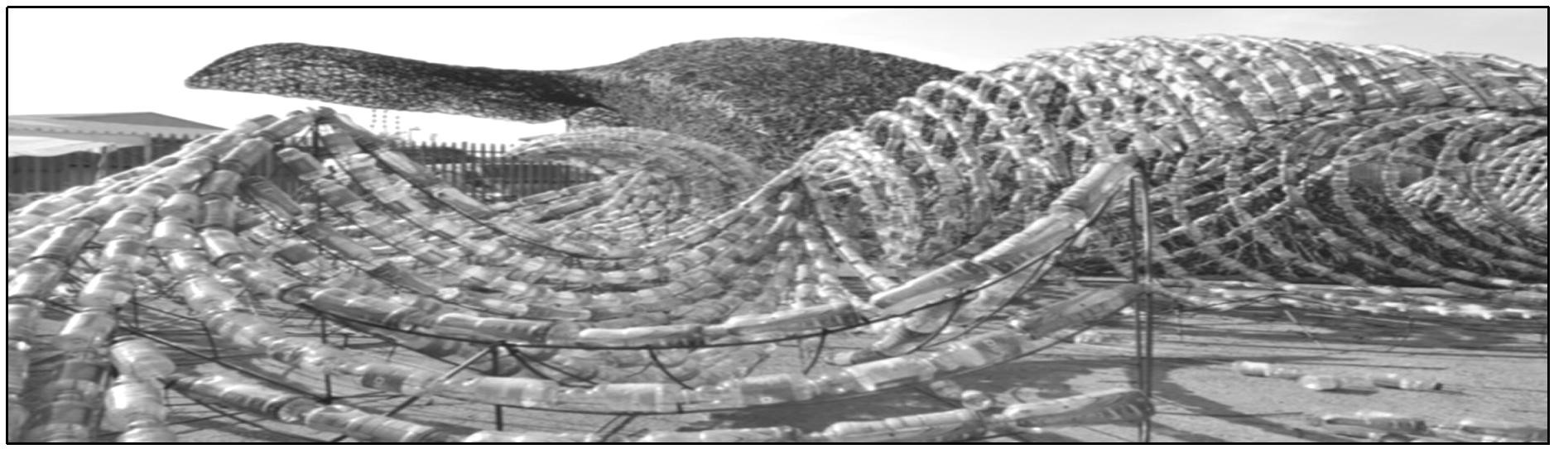

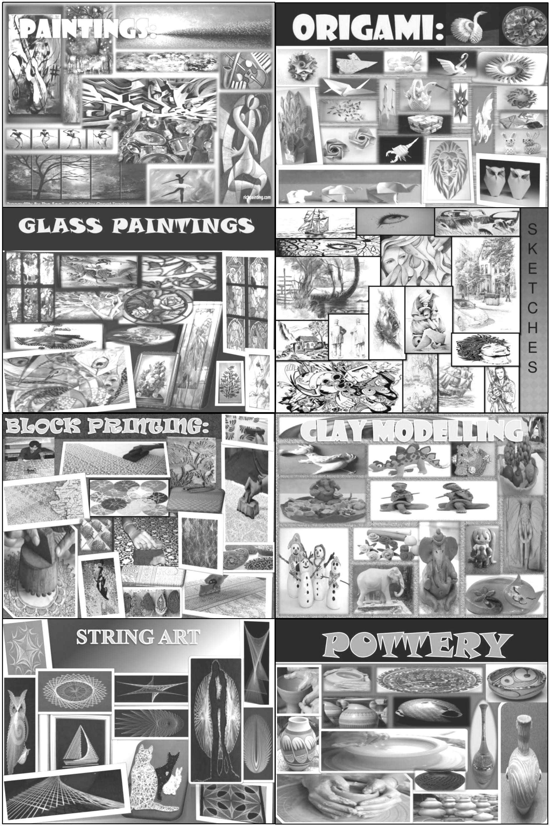

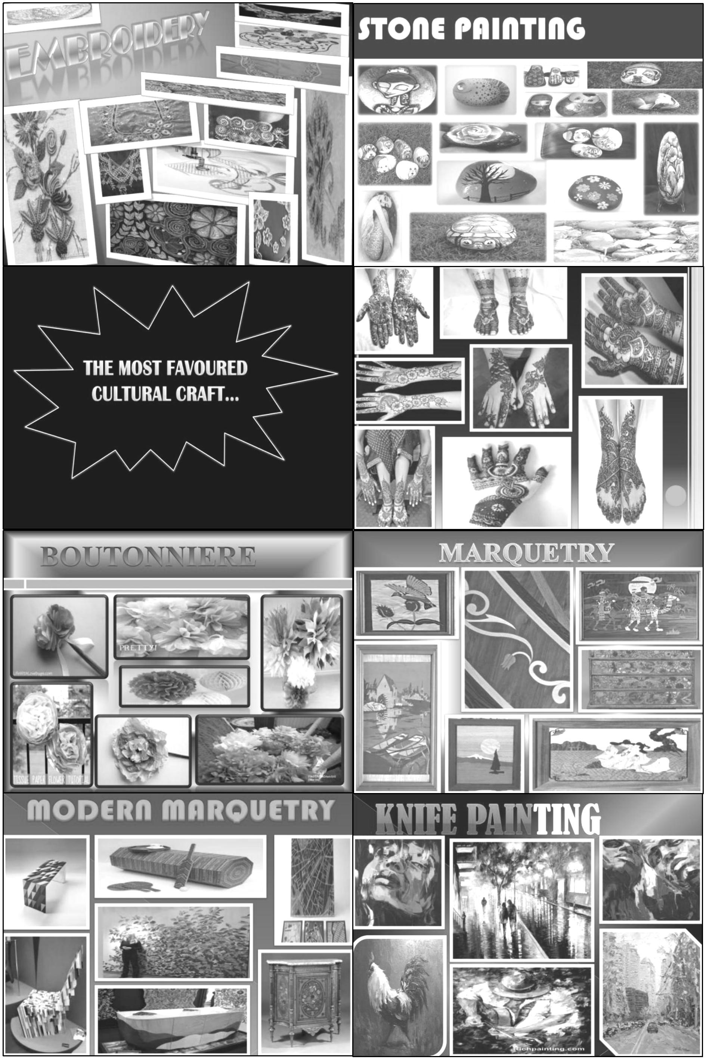

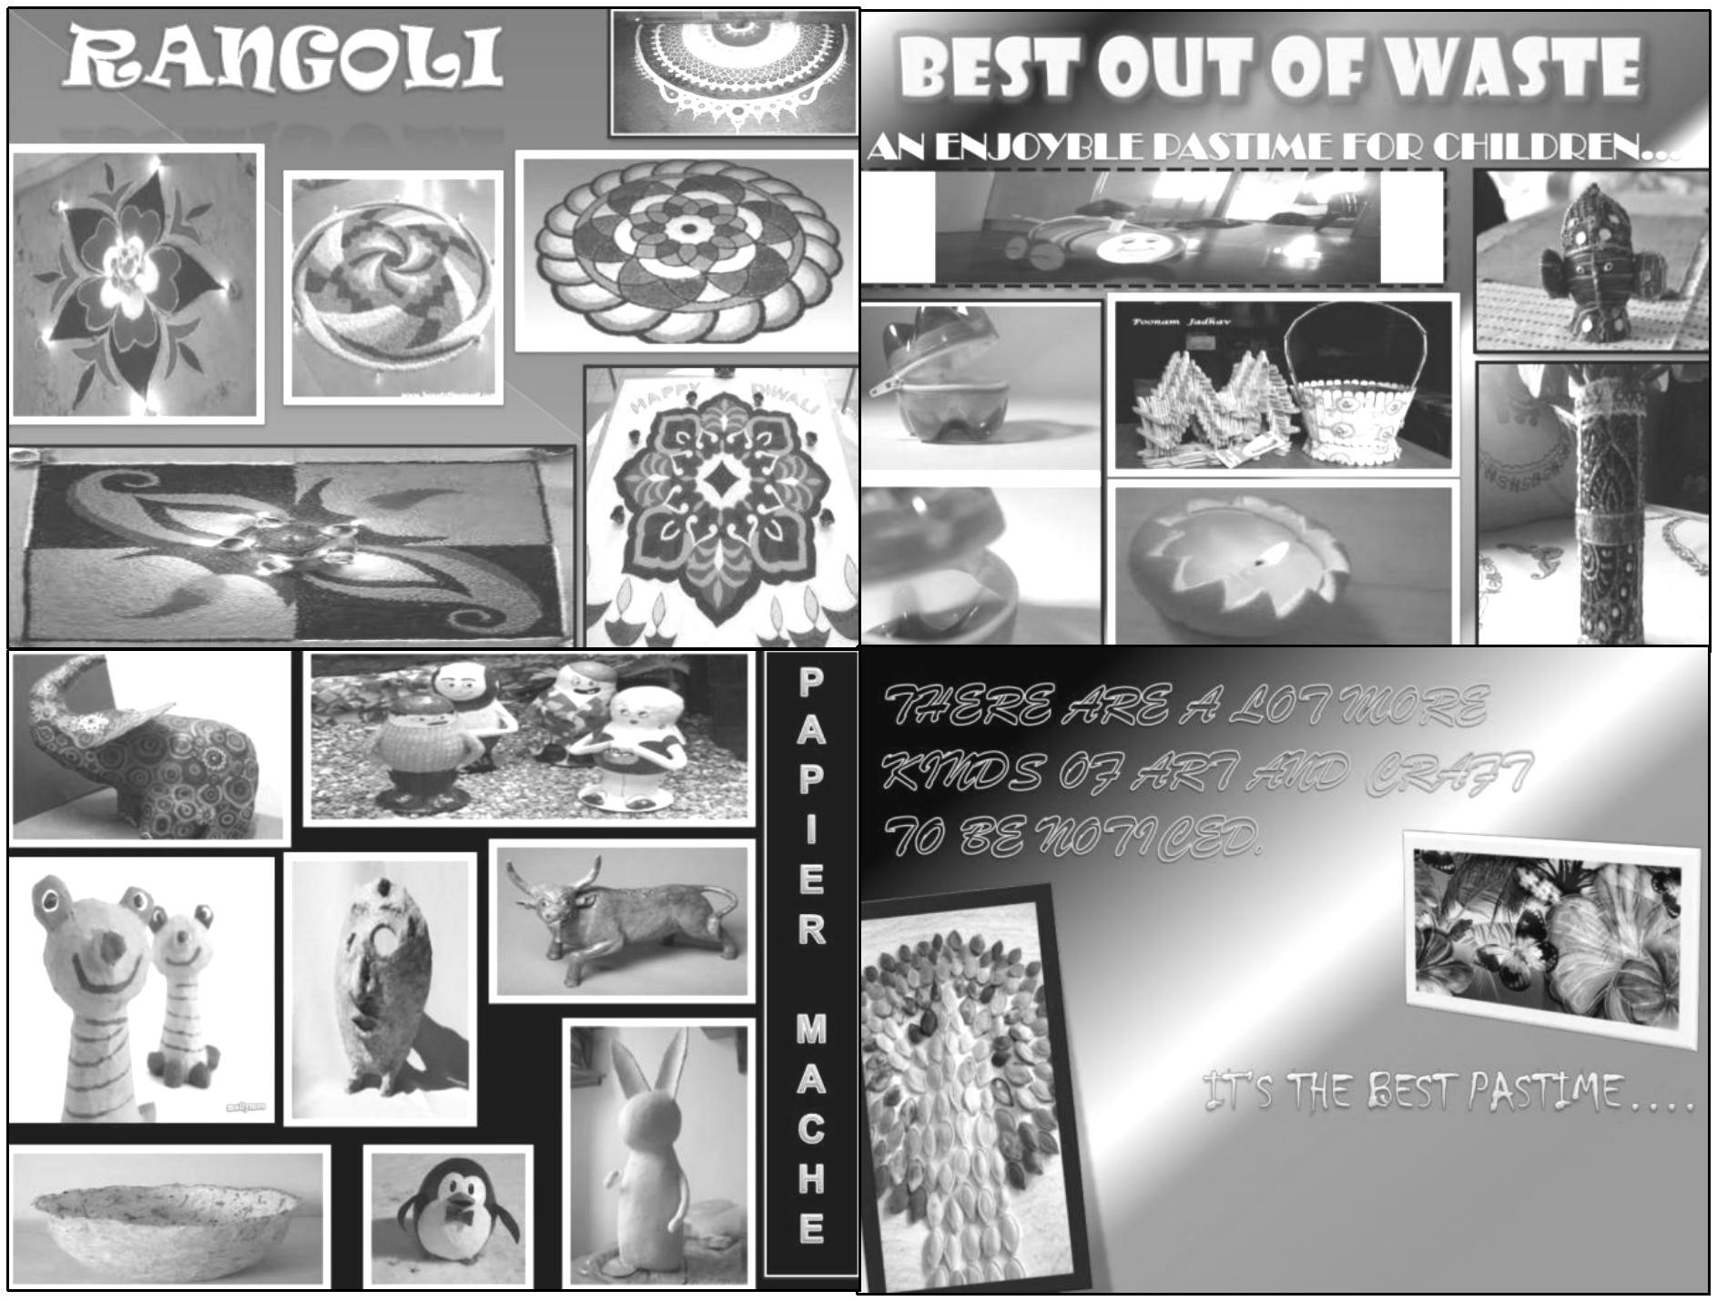

These are the sample arts and crafts production using appropriate materials. “Creativity will change the World of Art”.

|  |  |
| --- | --- |
| C:\Users\DEPED\Desktop\ADM specs\ADM cover and icons\ADM Icons\whats more.jpg | ***What’s More*** |

**ACTIVITY 2: SPOT THE DIFFERENCE**

You have already learned the different Expressionism Arts. This time let’s try how far your learning is. What you are going to do is to identify what are the difference between the two Expressionism art. Fill in the table below: The teacher will use rubrics for scoring.

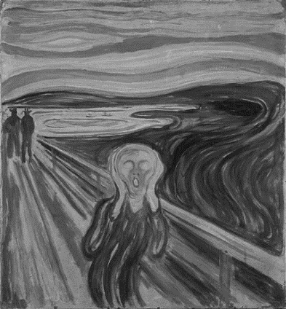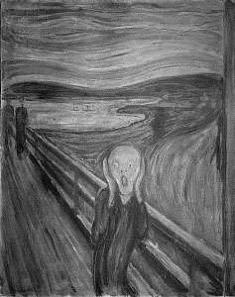

https://bit.ly/3p61xp9

https://bit.ly/3p61xp9

|  |  |
| --- | --- |
| **Painting A** | **Painting B** |
| 1. | 1. |
| 2. | 2. |
| 3. | 3. |
| 4. | 4. |
| C:\Users\DEPED\Desktop\ADM specs\ADM cover and icons\ADM Icons\Isaisip.jpg | ***What I Have Learned*** |

**ACTIVITY 3: SUMMARIZE**

Write a brief essay that answers the question, How do the artists incorporate the characteristics of contemporary arts to their artworks?

__________________________________________________________________________________________________________________________________________________________________________________________________________________________________________________________________________________________________________________________________________________________________________________________________________________________________________________________________________________________________________________________________________________________________________________________________________

|  |  |
| --- | --- |
| C:\Users\DEPED\Desktop\ADM specs\ADM cover and icons\ADM Icons\Isagawa.jpg | ***What I Can Do*** |

**ACTIVITY 4: CONTEMPORARY ART MAKING**

Create contemporary art using one of the techniques (abstract expressionism, surrealism, fauvism, or neoplasticism). You can make it using bond paper, illustration board, Oslo paper, or any medium you want. Write a brief explanation of your art. You can use the guide question below to write your explanation. The teacher will use rubrics for scoring.

Guide questions:

1. What is the title of your contemporary art?
2. What technique did you use?
3. What medium/s did you use?
4. What is the theme of your art?
5. What ideas do you convey to the audience of your art?

|  |  |
| --- | --- |
| C:\Users\DEPED\Desktop\ADM specs\ADM cover and icons\ADM Icons\Tayahin.jpg | ***Assessment*** |

**Post-Test**

**MULTIPLE CHOICE**.Write the letter of the best answer from the choices.

1. Which is not true about warm colors?

A. happiness C. excitement

B. violence D. dependability

2. Which is true about Neoplasticism?

A. straight lines and primary colors.

B. tapping into the unconscious mind to release creativity.

C. emphasizing the expressions of the self and emotions.

D. showing all of the possible viewpoints of a person or an object all at

once

3. Contemporary art is art that is living in _________________.

A. future times C. past times

B. present times D. mind

1. An art that emphasizes the expressions of the self and emotions.

A. Fauvism C. Neoplasticism

B. Abstract expressionism D. Cubism

1. A color that bring a calming effect to the mind.

A. Cool colors C. Warm colors

B. Bright color D. Dark colors

1. The technique that looks like they are made from cubes and other geometrical shapes.

A. Fauvism C. Neoplasticism

B. Abstract expressionism D. Cubism

1. Which of the following is not considered as a warm color?

A. Blue C. Orange

B. Red D. Yellow

1. Contemporary art is an art of ____________.

A. future times C. past times

B. present times D. mind

1. The most exciting components of a painting is _________

A. Technique C. Color

B. Design D. Medium

1. Sculptors used pieces of junk to produce _______________.

A. poetry C. novel

B. painting D. junk art

**Key to Answers**

**Pre - Test Post Test**

1. B 1. D
2. A 2. B
3. B 3. A.
4. B 4. B
5. C 5. A
6. D 6. D
7. A 7. A
8. D 8. B
9. A 9. C
10. D 10. D

**What’s New (Activity 1: Word Puzzle)**

* PERSPECTIVE
* EXTENSION
* GEOMETRIC
* VIRTUAL
* PRIMARY COLORS
* COLOR
* HARMONIES
* TERTIARY
* ANALOGOUS
* SURFACE
* VALUE SCALE
* GRAY
* PATH
* GRAY
* SPACE
* SITE
* VALUE
* SHAPE
* SHAPE
* COMPLIMENTARY

10

**Rubric for Grading Art Project**

|  |  |  |  |
| --- | --- | --- | --- |
| Points | Creativity/ Originality | Effort/ Perseverance | Craftsmanship/skill |
| 4 | The student explored several choices before selecting one, generated many ideas, tried unusual combination or changes, used problem-solving skills. | The project was continued until it was complete as the student could make it; gave it effort far beyond that required. | The artwork was  beautiful and patiently done; it was good as hard work could make it. |
| 3 | The student tried a few ideas before selecting one or based his/her work on someone else’s idea, made decision after referring to one source. | The student worked hard and completed the project, but with a  bit more effort it might  have been outstanding. | With a little more effort, the work could have been outstanding; lacks the finishing touches. |
| 2 | The student tried an idea but it lacked originally, might have copied work, and substituted “symbols” for personal expression. | The student finished the project, but it could have been improved with more effort, chose an easy project and did it differently. | The student showed average craftsmanship; adequate, but not as good as it could have been, a bit careless. |
| 1 | The student fulfilled the requirements of the assignment, but gave no evidence of trying anything unusual | the project was completed with minimum effort | The student showed average craftsmanship, lack of pride in finished work |
| 0 | The student showed no evidence of original thought | The student did not finish the work adequately | The student showed poor craftsmanship; evidence of laziness or lack of understanding |

**References**

“Indigenous Artists Who Have Kept Filipino Creativity Alive.” CNN. Accessed July 30, 2020. https://cnnphilippines.com/life/culture/2017/10/10/indigenous-artists-national-living-treasures.html.

“Order of National Artists.” National Commission for Culture and the Arts.

Accessed July 30, 2020.

https://ncca.gov.ph/about-culture-and-arts/culture-profile/national-artists-of-the-philippines/.

“Recognizing the Stranger: The Art of Emmanuel Garibay.” Image Journal, August 25, 2016. https://imagejournal.org/article/recognizing-the-stranger/.

“Chromolithography.” Omeka RSS. Accessed July 30, 2020. https://americanantiquarian.org/prang/whatisachromo.

Doroteja August, November 16, kanak November 19, chris August 17, Maleko August 17, Judy Fischer Walton August 18, Thomas Ahlswede August 18, et al. “Use The Hidden Meaning of Color In Your Art.” Fine Art Tips & The 2020 Club with Lori McNee, April 17, 2020.

https://www.finearttips.com/2009/08/use-the-hidden-meaning-of-color-in-your-art/.

Pinterest.com. *"The Buzzed Artist, Helping You Art With Confidence,"*

https://www.pinterest.ph/pin/586805026422139320/

Snopes Media Group In., *"Did a Sperm Whale Die After Swallow After 64 Pound Debris?,"*

Published April 12, 2018

https://www.snopes.com/fact-check/sperm-whale-die-swallowing-64-pounds-plastic- debris/

Laib, Wolfgang. "Word Press.com" *"Art Using Pollen,"*

https://discosaurus.files.wordpress.com/2010/04/laib_pollen6.jpg

Mashed Potatoes and Crafts *"Art Using Pollen,"* Crafted May 15, 2013.

http://www.mashedpotatoesandcrafts.com/2013/05/dyed-rice-mosaic.html

Pinterest.com. *"14 Awesome Works of Art Made Entirely From Stones That Will Leave You*

*Impressed,"*

https://www.pinterest.ph/pin/303007881177977751/

**For Inquiries or feedback, please write or call:**

Department of Education – Bureau of Learning Resources (DepEd-BLR)

DepEd Tagbilaran City Schools Division

Rajah Sikatuna, Dampas, Tagbilaran City

Telephone: (038)427-1702; (038)427-2506

E-mail Address: dtagbilarandivision@yahoo.com